K8s Deployment: <https://kubernetes.io/docs/concepts/workloads/controllers/deployment/>

Start using minikube start:

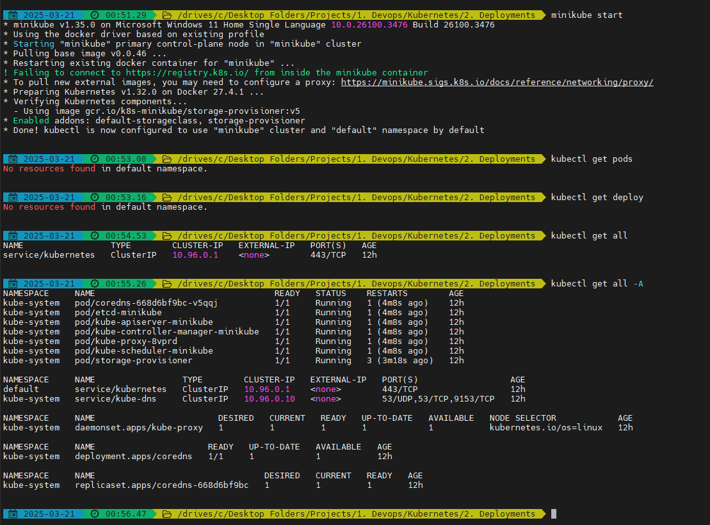

If you already have a deployment then delete is using:

* kubectl delete deploy nginx-deployment

How to list out all the resources in a name space:

* kubectl get all

How to list out all the resources for all the namespaces:

* kubectl get all -A

Create deployment yaml manifest:

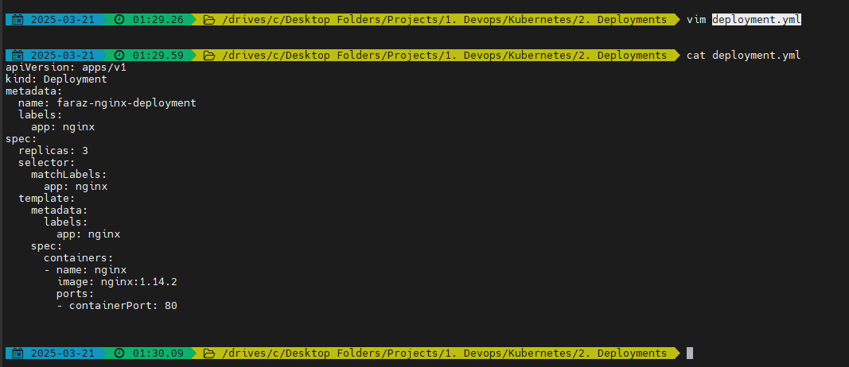

After running:

* kubectl apply -f deployment.yml

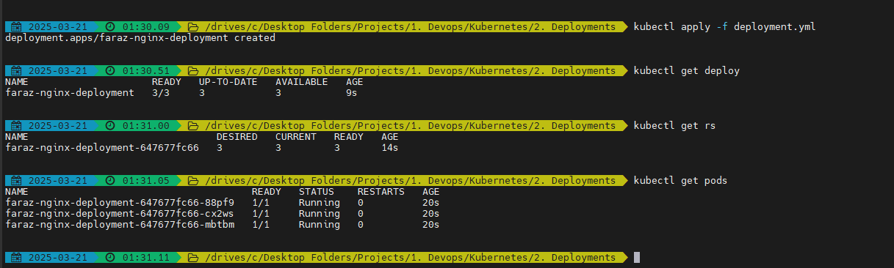

The deployment uses replicaset to create the number of Pods

* View your deploy, rs(replica set), pods

Note: K8s controllers (in our case replicaset) is a Go-lang application which will ensure that the specified behaviour is implement. The desired state = actual state

You can verify this behaviour using:

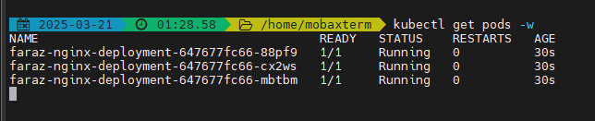

* kubectl delete pod <pod-name>

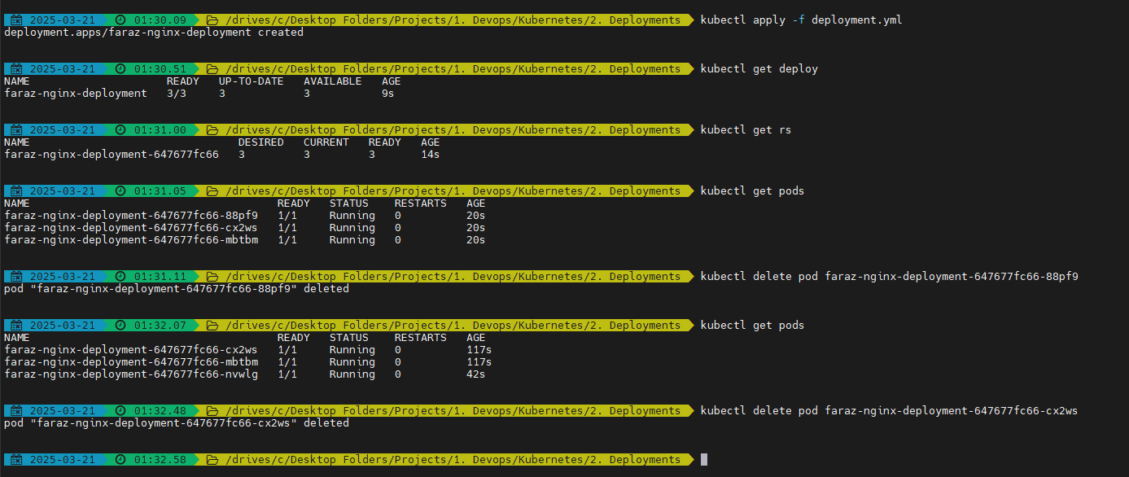

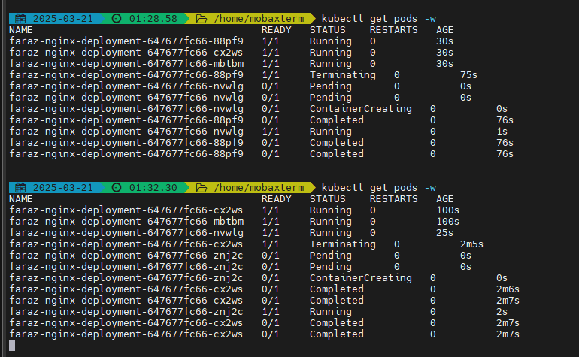

This helps in 0 downtime deployment

Delete the deployment using:

* kubectl delete deploy faraz-nginx-deployment

